# Part 2 Requirements

All hadoop commands are invoked by the bin/hadoop script. Running the hadoop script without any arguments prints the description for all commands.

Usage: *hadoop --config confdir COMMAND [COMMAND_OPTIONS]*

Execute each hadoop command once, and place the screenshots into a word file. If a command cannot be executed for any reason (such as, a distributed environment is needed), you may write the definition of the command, and skip execution.

http://hadoop.apache.org/docs/current/hadoop-project-dist/hadoop-common/FileSystemShell.html

# Accomplishments

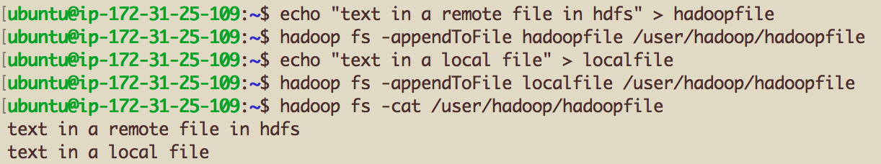



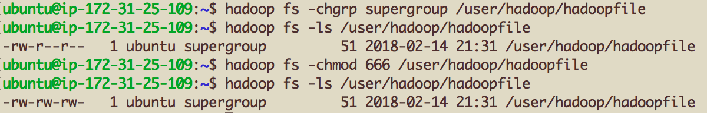

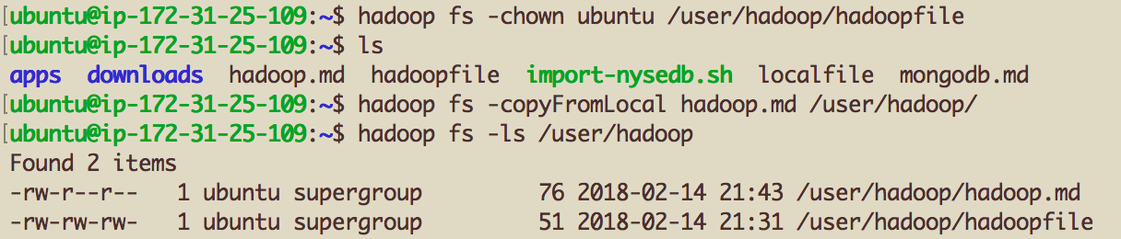



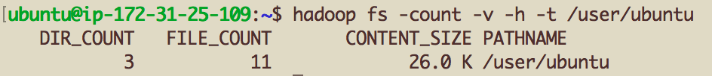

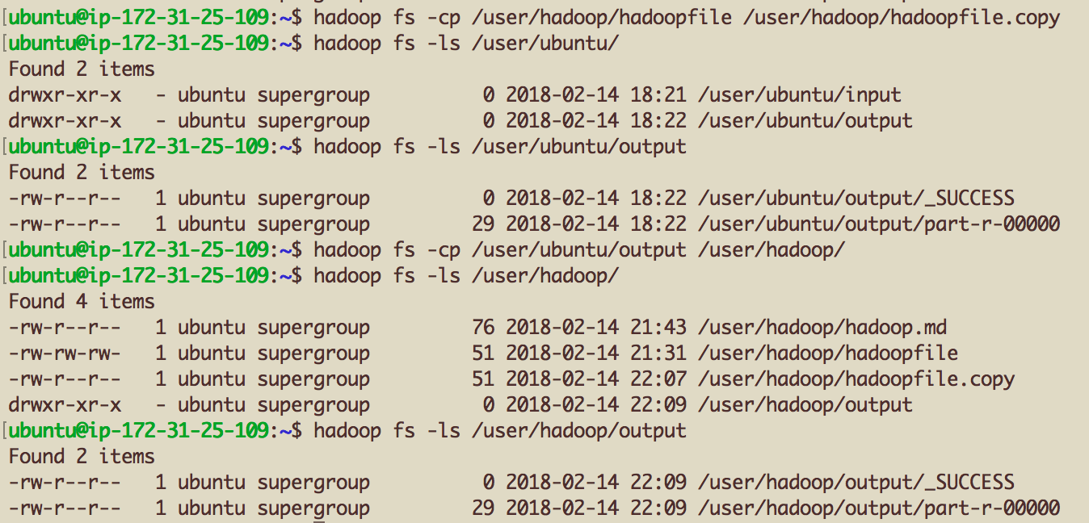

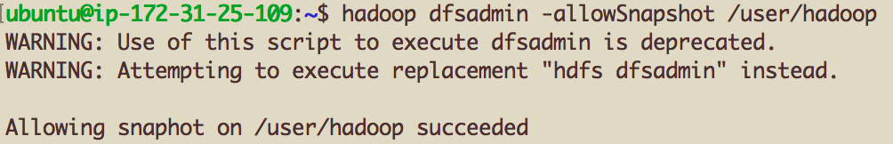

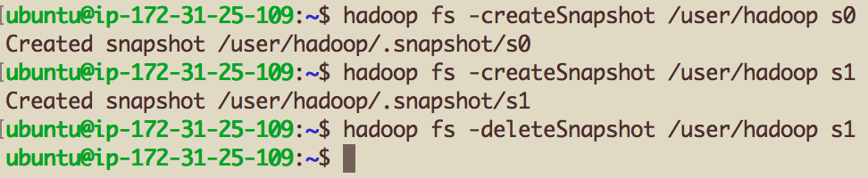

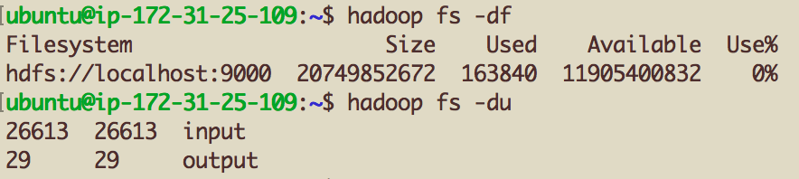

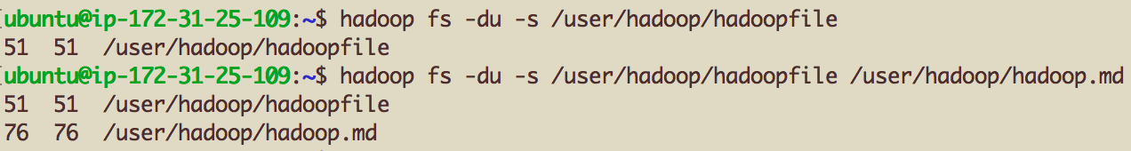

../../../../../../Desktop/Hadoop%20fs%202018-02-14%20at